Bahria University,
Karachi Campus
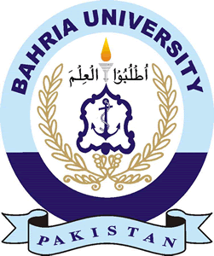

COURSE: Computer Programming
TERM: FALL 2022, CLASS: BSE- 1 (A/B)

PROJECT NAME

Engr. Muhammad Faisal/ Engr. Ramsha Mashood

Signed Remarks: Score:

HEADINGS:
- TABLE OF CONTENT
- INTRODUCTION & PROBLEM
- TECHNOLOGY
- CUSTOMIZE IN CURRENT PROJECT
- FUNCTIONALITIES
- MODULE DISTRIBUTION
- CODE
- INTERFACES
- CONCLUSION

